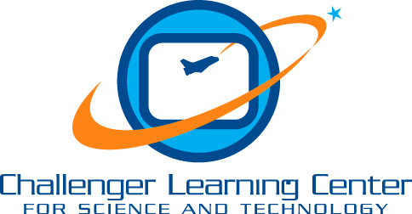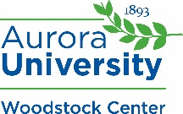
Media Release Form

Challenger Learning Center for Science & Technology of Aurora University

The students who visit the Challenger Learning Center often have the opportunity to work with the news media. Photographers from newspapers and television stations like to feature students in special news releases. In addition, the Challenger Learning Center periodically takes pictures of students in our programs for marketing purposes.
Please indicate below if you do or do not give permission for your child to be photographed and/or interviewed by members of the press.
Photo/Interview Agreement
Student Name __________________________________________________________________
Summer Camp Session Title (s) ___________________________________________________
Please indicate one of the following:
_____My child may be photographed/video-taped/interviewed during a visit to the Challenger Learning Center for Science & Technology of Aurora University. I hereby consent to the use of my child’s photograph, image, voice, written and/or verbal statements (materials). I agree to give all privileges for copyright and publication of my child’s materials, with or without my child’s name, for the use in publications, video-taping, advertisements, brochures, websites, etc. of the Challenger Learning Center and Aurora University (university) and for use in the media. I further acknowledge that there is no agreement or premise on the part of the Challenger Learning Center or university to compensate me or my child in any way for the use of my child’s materials in said manner. I hereby release the Challenger Learning Center and Aurora University from any and every claim, demand, right, or cause of action of whatever kind or nature, either in law or equity, arising from the use of my child’s materials.
_____My child MAY NOT be photographed/interviewed by the press or the Challenger Learning Center for Science and Technology Staff or media.

Parent/Guardian Signature ___________________________________Date_______________

